Team 18 Final Report

Sponsor:

Ron Goldstein

(Capital City Pedicabs)

Faculty Advisor:

Dr. Patrick Hollis

Instructor:

Dr. Kamal Amin

Members:

Ebere Onyewuchi

Andrew Galan

John Hassler

James McCord

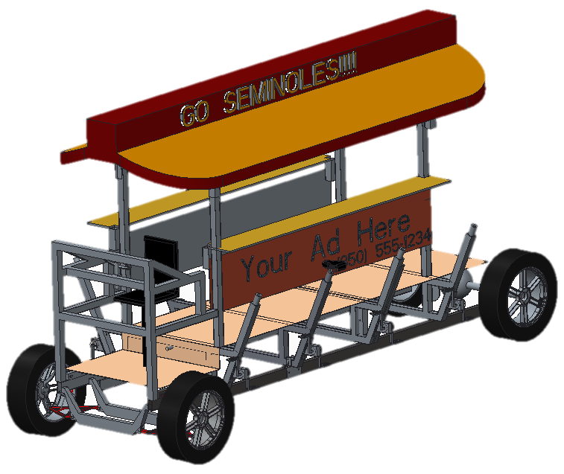

Pedibus Development

**Table of Contents**

Executive Summary………………………………….……………………………………..pg. 1

Acknowledgement……………………………………………………………………….....pg. 1

Project Overview…………………………………………………………………………...pg. 1

Design and Analysis………………………………………………………………………..pg. 2

Prototype Details…………………………………………………………………………...pg. 18

Design for Manufacturing…………………………………………………………….........pg. 21

Design for Reliability………………………………………………………………………pg. 21

Design for Cost……………………………………………………………………………..pg. 27

Considerations for Environment, Safety, and Ethics……………………………………….pg. 28

Communications……………………………………………………………………………pg. 28

Recommendations for Future Work………………………………………………………..pg. 28

Resources and Budget………………………………………………………………………pg. 29

Conclusion………………………………………………………………………………….pg. 30

**Executive Summary**

The senior design project of the Pedibus development was assigned to team 18 as a design and manufacturing project. The idea for the development was presented by the owner of Capital City Pedicabs, Ron Goldstein, as he had a want for a multi-passenger vehicle to entertain people of all ages and professions and add another vehicle option to his current Tallahassee Pedicab line. The first process of design started in the fall semester and consisted of three main concerns; the structural frame, the steering and braking, and the power generation. Multiple design ideas were involved for each concern and analyzed to find the best solution that provided safety and ease for both maintenance and operation. Once all ideas were presented and considered, the final selection for each individual component of the Pedibus was chosen. Leading into the spring semester, the manufacturing and construction of the vehicle began. Many complications and problems were encountered during the assembly process that delayed the production of the final product. After all problems were faced and overcame, the final construction was able to be completed and displayed at the open house. The completion of the prototype was very successful and provided the open house with enjoyable entertainment.

**I. Acknowledgement**

We wish to acknowledge the following for the respected support and guidance thus far into the senior design project development:

The Florida State University – Florida Agricultural & Mechanical University School of Engineering for allowing us the opportunity to work with external companies to gain project development experiences.

Instructor Dr. Kamal Amin for evaluation and positive feedback. Faculty Advisors Dr. Chiang Shih and Dr. Patrick Hollis for helping with problem solutions referring to the development of this project.

Special acknowledgement is given to Capital City Pedicabs, and in particular CEO, Mr. Ron Goldstein, for providing us with the sponsorship and opportunity to work on such a rewarding development project.

Special acknowledgement is also given to Jeremy Phillips, head machinist in the engineering machine shop for his constant support and advice in building the Pedibus. Without Mr. Phillips help there would be no Pedibus and the team is very grateful for all his efforts on our behalf.

**II. Project Overview**

The overall purpose through this development project is to aid in the assistance for Capital City Pedicabs is to start the production and manufacturing of Pedibuses in the southeast region of the United States. To do this the purpose of this year long project has been to develop concept ideas and analysis to review with the sponsor and lead to the construction of a fully operating road-ready Pedibus. The beginning process of this project dealt with structural and aesthetic concept designs. Kinematics and ergonomics were taken into account, as well as the budgeting and selection of necessary materials and items to construct the prototype. The second half of the allotted work time was devoted to constructing a fully operational Pedibus prototype that could be used as a model for future manufacturing.

**A. Project Goal**

Developing and manufacturing a fully functional prototype Pedibus by the end of April 2014, was the priority goal for the project. The development of the prototype provided information about dynamic and structural design, along with cost and maintenance recommendations. The Pedibus is an eco-friendly recreational vehicle and is safe to the public. It is efficient enough that it can be powered by only one passenger.

**B. Project Objective**

The objective of this project was to design and build a multi-passenger prototype vehicle that is powered by pedal inertia. The prototype will be used as a guide for the set up of a Pedibus manufacturing facility. The design was to take safety and maintenance considerations into account when considering every component. There are several parameters that had to be met to reach the final goal. These included:

* Developing the size of the vehicle based on the number of desired passengers and relative price points of the material and construction costs.
* Designing an appropriate frame structure that is lightweight and has optimal strength.
* Design the linkage system that will be connected to the drive shaft, to integrate a power drive system.
* Decide on the type of steering and braking to use on the vehicle that will provide a safe, comfortable ride.
* Decide on tires to reduce unwanted frictional forces
* Construction of a road ready prototype vehicle based on these design criteria.

**III. Design and Analysis**

The design of the Pedibus can be broken down into three main subcategories; structural frame, steering and braking, and power linkage. These are the main components that required numerous conceptual designs and analysis to ensure to cheapest, lightest, and safest Pedibus.

**A. Function Analysis**

The Pedibus is developed around the idea that it is an eco-friendly, pedal inertia powered entertainment vehicle. The passengers are assigned to individual peddling stations and as the peddles move and rotate the operating components the vehicle will begin to move; much like a common bicycle. The proceeding section will discuss the functionality of each major subcategory.

**i. Structural Frame**

The primary task of the frame is to tie together all of the separate components of the vehicle in a safe and secure fashion. Considerations taken into account in design of the frame are strength, safety, weight, and maintenance. Strength is the most pivotal aspect. The frame needs to be strong enough to withstand forces larger in magnitude than what is to be expected in normal operation. Primarily, the loads will be downward forces, but lateral forces as well as acceleration and deceleration forces are taken into account and planned for.

**ii. Steering and Braking**

The control operation of the Pedibus has to be safe and simple to provide ease of maintenance and control. The steering system is responsible for turning the wheels either left or right depending on the orientation of the wheel determined by the central driver. As the driver rotates the steering which through a gear set will translate the rotational motion into a linear transitional motion. Once the Pedibus is in motion, determining the best stopping method has to be taken into great consideration to apply the best possible public safety. Normal automobiles have brakes that are used to reduce the speed of a vehicle to come to a complete stop. The same idea goes into the stopping of the Pedibus. As force is applied to the brake pedal by the driver the rotor will begin to slow down until all kinetic energy is lost and come to a complete stop. Both braking and steering are located at the front central driving station, and not at the pedaling stations, to ensure that the proper steering and braking applications are made.

**iii. Power Linkage**

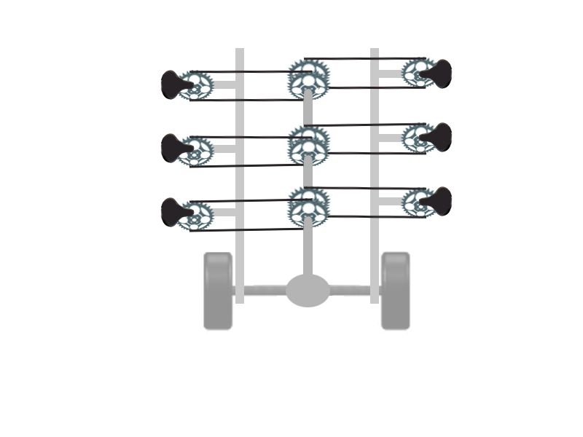The power linkage of the Pedibus system works under the principle that the passengers input the power required to move the vehicle. This power input is accomplished by the passengers pedaling at the pedaling station. The pedaling power input by all passengers is then converted into the motion of the Pedibus. Early in the first semester the Pedibus team researched how other Pedibus manufacturers had accomplished this transmission of power from the pedals to the wheels of the vehicle. Viewing the information posted on several different Pedibus manufacturers’ websites it was observed that all existing Pedibuses have the pedaling power input to a central drive shaft. This drive shaft is connected to a rear differential from an automobile. After exploring other options through the course of the first semester the Pedibus team has decided to implement this functional design in the vehicle we are developing. Figure 1 is a simple diagram of how our team initially visualized the linkage between the pedaling stations, drive shaft, and rear axle of the vehicle.

Figure 1. Initial Power Linkage Design

**B. Design Analysis**

The design of the prototype is the back-bone to the Pedibus development. Multiple concept design and errors had to be overcome to provide the most simple and safest design. The design of a prototype is the stepping stone for possible production, since it is typically the first thing a company brings a consumer to review. The designs that will be discussed have been analyzed and chosen for the ease of maintenance and reliability. At the end of each section any design changes made during manufacturing and assembly will be discussed.

**i. Structural Frame**

The weight of the frame is a large factor in how much power input each of the passengers of the Pedibus will need to input to accelerate and maintain its velocity at the desired cruising speed of 5 mph. Due to the tourist friendly nature of the vehicle, an enjoyable experience for the passenger is necessary. The lighter the frame the more enjoyable the experience for the passenger. In an effort to minimize the weight of the frame as much as possible, while still retaining strength, different materials were explored. The primary materials taken into consideration were steel and aluminum. Steel is a very strong material and monetarily fits within the budget. It is roughly 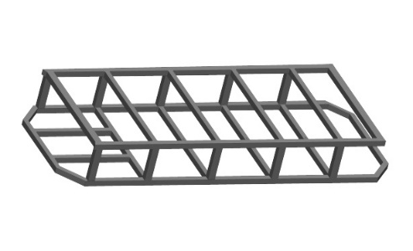twice as strong and three times as heavy as aluminum. The initial lower frame design composed of only steel and is shown in figure 2. This frame was made of 2x2 rectangular tubing with wall thickness of 0.125 in. It was 110 ft of material in all, the price of the raw material was sourced at around $900, and it weighed in at 460 lbs. This was far too heavy, as none of the drivetrain, suspension, steering, or bicycle components are included in that weight.

Figure 2. Initial all steel frame design

It is not a question whether or not this steel frame is strong enough for our application, as many of the Pedibuses today use a very similar all steel cage construction, but since our Pedibus is going to be crawling the streets of our very hilly college town, opportunities to cut weight by a more efficient frame design were explored.

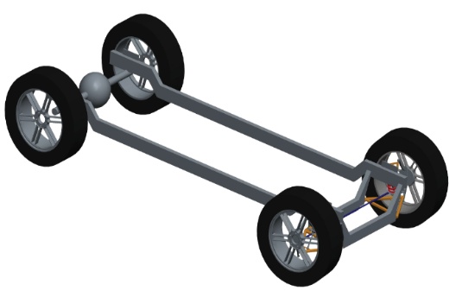 A frame consisting of all aluminum would be ideal, though the amount of extra aluminum support to counteract the drooping of the frame across the span between the front and rear tires would be so thick with the struts, supports, and cross members so much that it would not allow for much room for maintenance of drivetrain components, which is not optimal. This issue led to exploring the idea of a steel and aluminum frame. Consisting of two main steel rectangular supports spanning from the front end components to the rear axle supporting the weight load of the passengers and aluminum frame which will be rested atop of the steel beams, shown on the figure 3.

Figure 3. Steel support beams for aluminum cross members

When consulting with an experienced welder regarding the design of the crossmember the suggestion was made to extend the side beam of the cross member to increase the overall strength of the seat mount. The adjusted crossmember geometry is shown in figure 4.

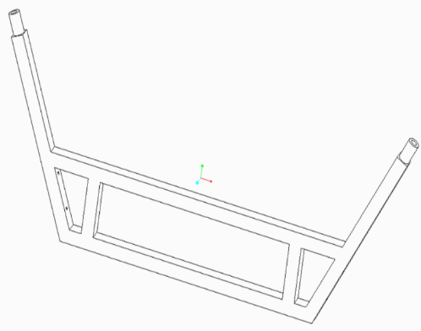The considerations for the seat mount on the crossmember to facilitate implementation of mass produced bicycle seats that the sponsor’s bike mechanic can source for a lower price. This includes a 27.2mm diameter seat mounting hole that is the general standard for bike seat posts. This also provides versatility in the design such that if a smaller child will be sitting at a pedaling station, a childs bucket seat can easily be mounted in stead of a standard bike seat. In the pedibus prototype produced this seat post collar was more complex. It was milled from a billet of aluminum and welded in place at the end of the crossmember.

Figure 4. Finalized cross member geometry

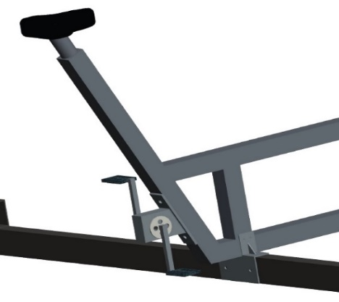The mounting of the bicycle pedals, crank, and gears to the cross member were designed to be accomplished by two mounting holes on each side beam of the cross member. The entire assembly of the crank mounted onto the crossmember is shown in figure 5. Making the bike components detachable from the crossmember would make them much more accessible to the bike mechanic who will be maintaining the pedibus, the detachable portion will include the pedals, sprocket, and the free wheel. Unfortunately this design did not account for the stretching of the chain and had to be changed to a sliding mechanism that could be moved closer or further away from the central drive shaf to adjust the chain tention. A picture of the crank attachment used on the final pedibus can be seen ing Fig 6.

Figure 5. View of bicycle crank and support bracket mount on cross members.

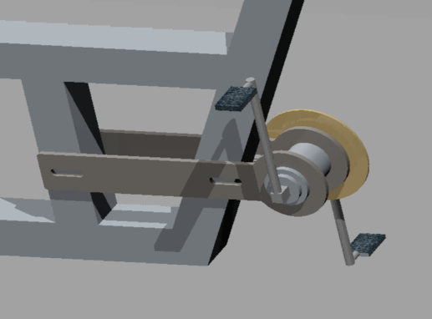With the design of the cross member finalized the issue of how to attach the aluminum cross member to the steel frame is made pertinant. The mount needed to incorporate resistance from the cross member from tipping forward or backward which will be the largest force that the mount will need to resist. Keeping the crossmember from moving laterally will be a much smaller force to prevent from occuring. This is an aspect of bracket design that can be capitolized on, since drilling and removing any material from the aluminum can weaken the material and make the FEA analysis less accurate.

Figure 6. modified crank attachment

The Proposed design of the bracket to fasten the Aluminum cross members to the steel support struts is shown in figure 7, the primary objective of the bracket is to prevent a tipping moment, as well as to secure the aluminum to the lower steel beam. Considerations taken during the design of the bracket are the material of the bracket, steel, and an effort to minimize any drilling into the aluminum, which would jeapordize structural integrity of the upright within the crossmember. The bracket was designed to be secured to the lower steel beam with nuts and bolts through the 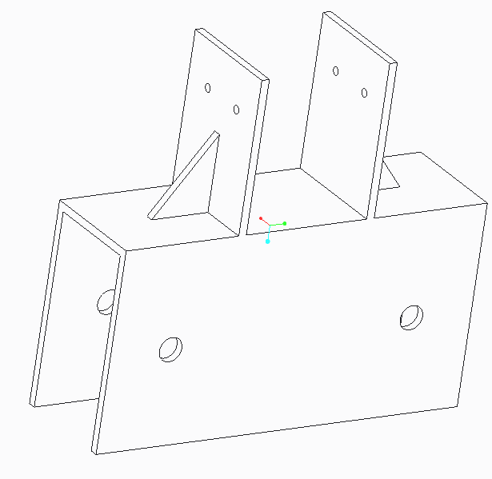predrilled 3/8 inch holes in the steel beam and the bracket. Washers and lock washers would be used to ensure the bolt will not loosen with vibration. Securing the crossmember to the bracket would be accomplished in a similar method to how the bracket was secured to the steel frame, except the predrilled holes through the aluminum and bracket were designed to be 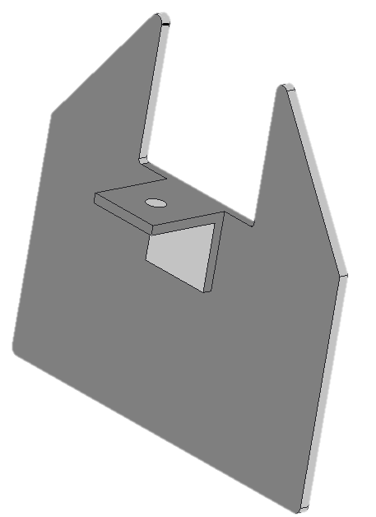1/16 inch. The holes in the aluminum bracket are primarily preventing lateral translation so they did not need to be as large as the holes in the steel beam, as those mounting holes will be preventing the tipping moment of the crossmember which would be a far greater force. To triangular flange was included to prevent any bending of the crossmember mounts. The bracket design is shown in figure 7. This bracket design underwent some design changes during the manufacturing process to make it easier to build. The final bracket design can be seen in figure 8. In addition the gussets on the bracket were deemed insufficient to keep the crossmembers from experiencing a tiping moment. To keep the frame rigid additional aluminum supports were welded between each crossmember linking them all together and increasing the strength of the frame.

Figure 7. Original bracket design

Figure 8. Finalized bracket geometry.

The sponsor of this project wanted to have an adjustable bar top height to accommodate different sized riders. This was to be achieved by four primary posts protruding through the walking platform above the crossmembers. The posts are mounted and welded to the top of the frontmost and rearmost crossmembers and are linked at the top at corresponding mounting locations of The umbrella top, where gusset plates would be implemented to prevent any sway within the bar posts.

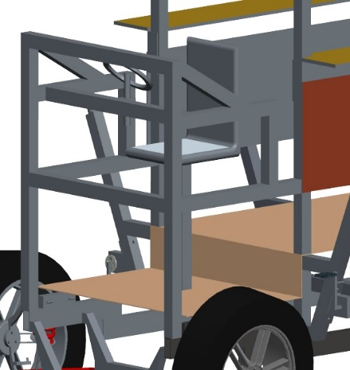The bar will be adjustable upon these posts by a pin and sleeve system where various predrilled holes can be used as different height mounts for the bartop. The material for the bar top will be a hard wood, similar to that of bar tops in restaurants or bars. it will be treated to be moisture resistant, but it will not be as thick or heavy. For safety the bar top will have handle holes cut into it at corresponding locations for each passenger. The aluminum frame will wrap around the front of the pedibus, and will be mounted to the lower steel support via brackets and will be welded to the front two bar posts to further enhace the strength of the bar posts, though the weld location will be below the lowest bar height adjustment setting as to not interfere with the bar top adjustability. A picture of the front aluminum structure is shown in the figure 9.

Figure 9. View of front driving station

**ii. Steering and Braking**

When the Pedibus is traveling and moving along the road, it is important to know the design behind its operating and controlling components. In steering and braking there are various aspects that decide whether a system is desirable or not. For steering there were two basic designs that were taking into consideration. The rack-and-pinion steering system and the recirculating-ball steering system. Both systems are reliable and simple, and after large amounts of research the rack-and-pinion steering was chosen to be the best system for the prototype design. Recirculating-ball steering is often used for heavier vehicles that required gear reduction to reduce the amount of frictional forces for easier steering. In the case of the Pedibus, the unloaded total weight of the vehicle is relatively light compared to that of a normal automotive vehicle and does not involve complex gear reduction.

*Rack-and-Pinion Steering*

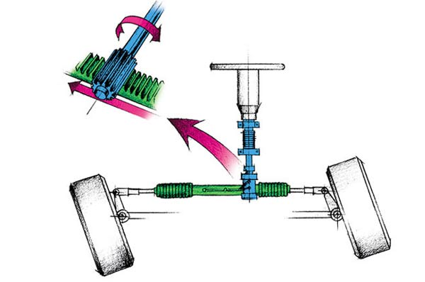Rack and pinion steering is common in early cars and currently used in most automotive and other Pedibus designs. The rack-and-pinion is the most simple gear set used in steering control and is typically enclosed in a metal casing tube. Referring to figure 10 it is noticeable that a pinion gear, located at the bottom end of the steering shaft, is connected to a horizontal gear rack. As the orientation of the steering wheel changes, due to driver commands, the pinion gear will rotate in a fixed position. The interactions with the gear rack will convert the rotational motion of the pinion gear into transitional linear motion of the rack from left to right. At both ends of the rack is attached a tie rod. These tie rods conjoin to the steering rods located at the upright or spindle of the wheels. This series of components allow for the driver to change the direction of the wheels with ease and have complete control of the Pedibus.

Figure 10. Rack-and-Pinion steering system

In order to secure the safety of the vehicle, the passengers, and the public the braking system implemented has to be very tuned and observed in detail for best selection. Most cars today use disc brakes in the front because of the reliability and simplicity of the system. Once research had been concluded, it was found that disc brakes would also be the best application for the prototype vehicle.

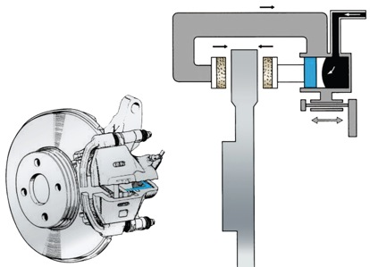*Disc Brakes*

The braking system has to be able to bring the loaded assumed 3000lb weight of the Pedibus to a complete and safe stop, for both the driver and passengers. Disc brakes consist of three main instruments: the rotor, the calipers and brake pads, and the fluid brake lines. As the brake pedal is compressed by the driver and force is applied the push rod begins to extract braking fluid out of the master cylinder. Once the fluid has left and travels through the hydraulic brake lines into the secondary cylinder. With constant pressure from the fluid the piston, located at the secondary cylinder, conforms and compresses towards the rotor, seen in figure 11. The piston itself does not come into contact with the rotor, instead there are calipers that are used for contraction. On the inside of the calipers are brake pads on each side of the sidewalls of the rotor. As the brake pads become tighter around the rotor, the kinetic energy begins to convert into heat. The reason for disc brakes being so reliable is that they only respond to the amount of force applied by the driver, securing a safe stopping method.

Figure 11. Completed disc brake and frontal view.

To incorporate the rack and pinion steering and hydraulic disc brakes it was decided that the final prototype would have a Mustang II independent front suspension. This front end used rack and pinion steering and hydraulic disc brakes that are strong enough to stop a full sized automobile moving at speed of 8mph. The front end was purchased as a kit online and had the added feature of independent suspension for both tires making for a smoother ride.

**iii. Power Linkage**

Picking the functional design was made simple by looking at the websites for other Pedibus manufacturers and observing the general principals by which their Pedibuses are powered. What isn’t made clear on the manufacturer’s website is how they link the pedaling power from the passengers to the drive shaft. One problem that is immediately apparent with this design is that passengers on opposite sides of the Pedibus can’t both pedal forward. To address this issue we developed a number of different designs for the linkage between the pedaling station and the drive shaft. Ultimately the team decided that flipping the chains on one side of the Pedibus as they connect to the drive shaft. By flipping the chains the rotational input to the drive shaft is effectively reversed as seen in figure 12.

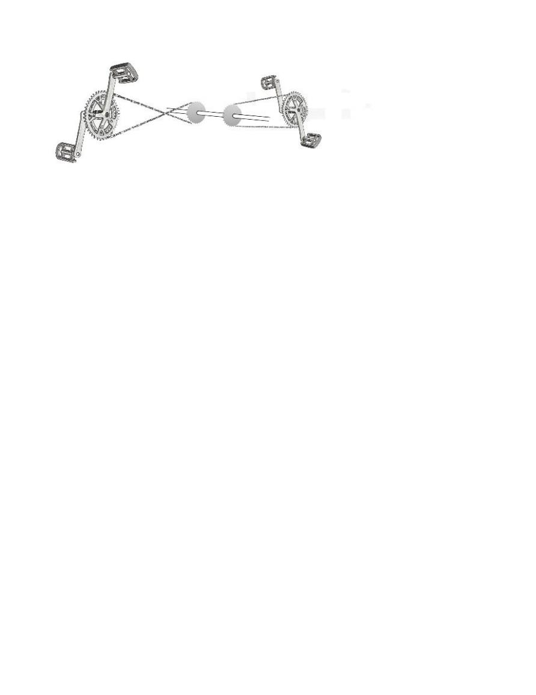

Figure12. Linkage between the pedaling station and drive shaft

The benefits to this design are that all passengers can pedal forward and that it requires very few additional components over other design concepts. Slightly longer lengths of chain will be required for all the pedaling stations on one side of the Pedibus to account for the longer distance required to cross the chains. The negative aspects of this design are believed to be minimal. Without adding some additional parts to keep the chain links from rubbing against each other as they cross the life span of the bike chains will be reduced. To counter this potential reliability issue a set of pulleys will be installed to guide the chains around each other. A 3D model representation of what this would look like on the final Pedibus prototype can be seen in figure 13.

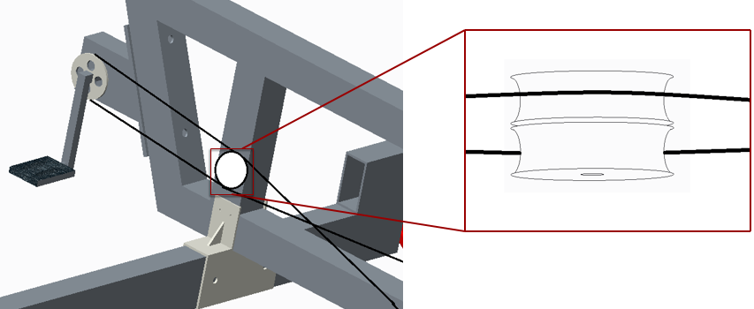

Figure13. Pulley placement on cross member

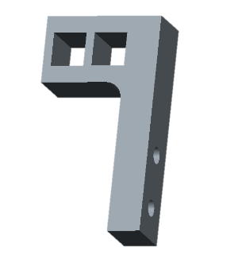In the final prototype many different pulley designs were tested. The two separate pulley design illustrated in figure 11 was not completely succesful in keeping the chains from rubbing together. The biggest problem was that keeping the chains from rubbing together required increasing the chain deflection. Increasing the chain deflection resulted in the chain slipping of the bike sprocket on the central drive shaft. Of the many designs experimented with for a chain separator the most effective can be seen in figure 14. It is simply two guide holes water jetted out of a block of hard delron plastic.

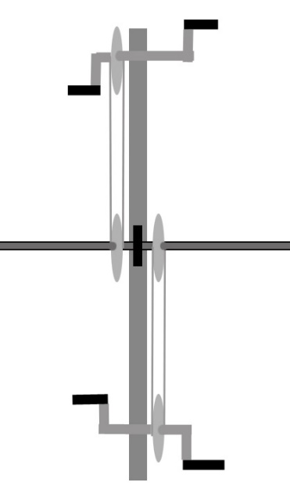In the initial visualization of the power linkage it was believed that the pedaling stations would have to be offset from each other so there would be room for all the gears on the bike shaft. This configuration can be seen in figure 1. After designing the frame it was decided that the pedaling stations could be attached to the same cross member support and the pedaling gears and chain installed on the cross member as seen in figure 15. This layout for the pedaling mechanism allows for a less complicated assembly of the Pedibus.

Figure 14. Modified chain separator

Figure 15. Top view of cross member with bike components.

The drive shaft itself is ¾ inch cold rolled steel rod. The drive shaft is designed to be connected to the structural frame of the Pedibus by pillow blocks which are bolted to the undersides of the four cross members that make up part of the structural frame of the Pedibus. Figure 16 gives a better reference as to where on the Pedibus these pillow blocks are installed. It can also be seen from figure 17 that the drive shaft is designed to be keyed so that the bike gears can be attached to the drive shaft without having to be welded onto the shaft. The key between the drive shaft and the bike gear hub keeps the bike gears rotation locked to that of the drive shaft. Two collars with set screws are installed on either side of each gear so that the gear doesn’t slide on the drive shaft. This allows for easier maintenance of the Pedibus in that if one of the gears breaks the collars and gear hub can be removed, the gear slipped of the shaft, and a new one slipped back on in its place. It is important to note that if the middle gear breaks all gears between that gear and the end of the drive shaft will also have to be removed which is much easier to do with gears keyed to the drive shaft than with gears welded to the drive shaft.

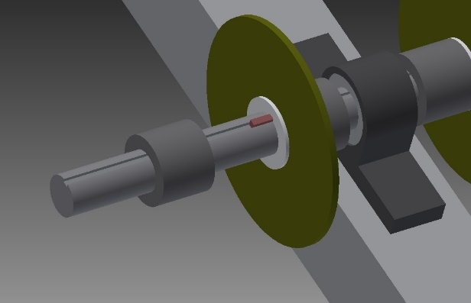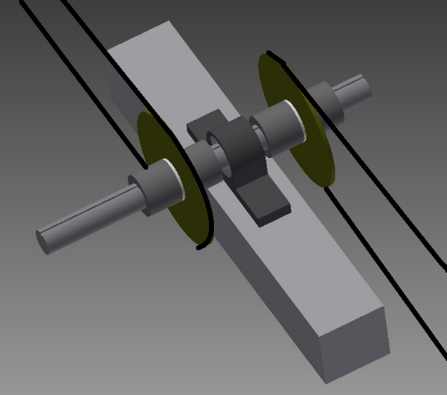

Figure 17. Keyed drive shaft assembly

Figure 16.. Bike gear and pillow block assembly

The drive shaft is connected to a repurposed rear axle of an automobile. The driveline input for the differential has a larger diameter than the ¾” driveshaft it is being connected to. A piece of A36 cold rolled steel round stock 2.5” in diameter was machined to fit inside the driveline of the rear differential and had a ¾” hole bored through it to fit the drive shaft. The pieces are welded together to bridge the connection between the drive shaft and rear differential. The rear differential originally being sought after was the rear end of a Toyota T100 truck. The Toyota T100 has a rear differential gear ratio of 3.08:1. Ultimately the team could not locate a Toyota T100 rear end and used a 1991 Chevy Camaro rear end instead. The Chevy Camaro rear end has a gear ratio of 3.23:1. The differential gear ratio is an important figure to know for calculating the bike gear ratios between the drive shaft and the pedaling stations as will be explained in that portion of the analysis section later in this report. The rear axle transmits the power input by the driveshaft to the rear tires of the Pedibus.

The tires chosen for this vehicle were chosen based on their coefficient of rolling resistance. As is explained in further detail in the analysis section of this report the dominant force that must be overcome to maintain the desired cruising speed of the Pedibus is the force of rolling resistance. The easiest way to minimize the force of rolling resistance is to pick a tire with the lowest coefficient of rolling resistance. The Michelin Symmetry P225/60R16 has a rolling resistance coefficient of 0.0065 making it one of the lowest rolling resistance full sized tires on the market. The tire fits a 16” rim and has a total inflated diameter of 26”. All analysis was done with this tire in mind for the final product. On the completed Pedibus prototype spare tires were used instead.

**C. Dynamic Analysis**

Knowing the design and skeleton behind the development of the Pedibus only deals with the functional and aesthetic image of the vehicle. The real success of the project is due to the mathematical and computer dynamic analysis that went into every component. Knowing characteristic properties and limitation, eliminates room for error and undesirables results.

**i.Structural Frame**

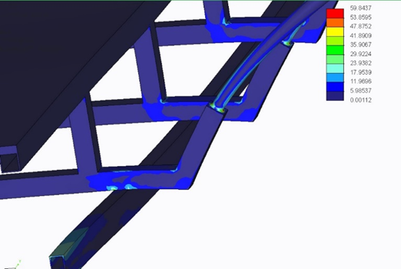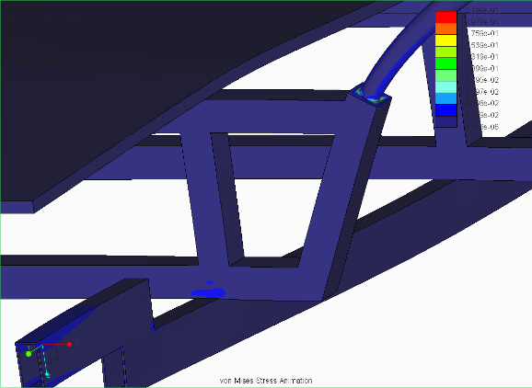The design of the cross member was a dialing in process, FEA analysis was used to ensure that the design of the cross member would complement the lower steel beams in a fashion which yielded the maximum strength possible. The initial design for the incorporation of an aluminum and steel frame yielded less than desirable FEA static load analysis results. Shown in figure 18 is the results of the static load analysis of the first proposed design of the cross member. The analysis was performed with a uniform distributed load of 1000 lbs. across the diamond plate aluminum platform that rests atop the 4 cross members and an additional load of 300 lbs. was placed at the seat mounts of each of the 8 pedaling stations. The areas of light blue are stresses above the yield strength of aluminum and the blue areas are areas of stresses that are near the yield stress of aluminum. The results of this test were concerning and the design of the aluminum cross member was modified and reanalyzed.

Figure 18. FEA analysis of initial aluminum cross member design

The modifications made to the cross member include positioning the cross member uprights above the steel beams and pulling the side beams in closer toward the steel supports. As shown in the static load analysis of the frame after the adjustments were made to the cross member in figure 19, the areas of stresses have been greatly reduced and there is no stresses above the yield strength of aluminum present.

Figure 19. FEA analysis for modified cross members

**ii. Steering and Braking**

With the decision to use rack-and-pinion steering the Pedibus is designed to have an automotive vehicle steering feel. The driver will turn and control the vehicle by means of a common steering wheel. Since the Pedibus is made as an entertainment console and is not going to be operating at high speeds, the turn radius is going to have to be able to make tight corners. The sharpness of the turn and responsiveness is due to the pinion diameter and gear rack length. The maximum turning angle of a normal rack-and-pinion steering is at about 60 degrees. This large angle allows the Pedibus to take tight corners when the steering wheel is rotated fully.

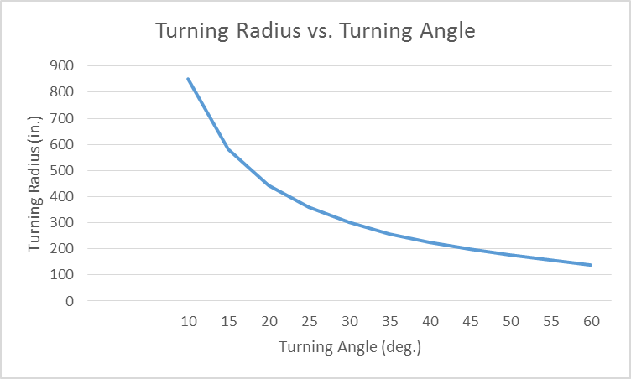

Figure 20. Analytical graph of turning radius vs. turning angle

Looking at the graph in figure 20, It can be observed that as the turning angle begins to increase, in degrees, that turning radius reduces as a result. This is a normal characteristic of steering and proves desired results. A balance equation was used to find the opposing lateral forces that may be applied during cornering. Detailed mathematical analysis and equations are performed in the appendix.

Once the Pedibus is in motion, the next concern is bringing it to a safe and complete stop. The braking force is applied by the front central driver and controls the distance that the Pedibus will come to a stop. An assumption of the driver weighing around 200 lbs. was made to give an assumed applied braking force of between 0 lbf when no force is applied, to 100 lbf when maximum force is applied. Forces that had to be overcome, and are detailed in the appendix, included: the brake pedal, brake pads, calipers, friction of rotor, and fluid pressure forces, as well as the tire forces. A graph was compiled, as seen in figure 21 that shows if the assumed driver were to apply any force greater than 40 lbf. that the Pedibus will stop within one foot. Also we can conclude, the slower and softer the driver exerts force to the brake pedal the slower that rate of stopping as well. The results put confidence into the brake system chosen as it provides a safe and efficient stopping method.

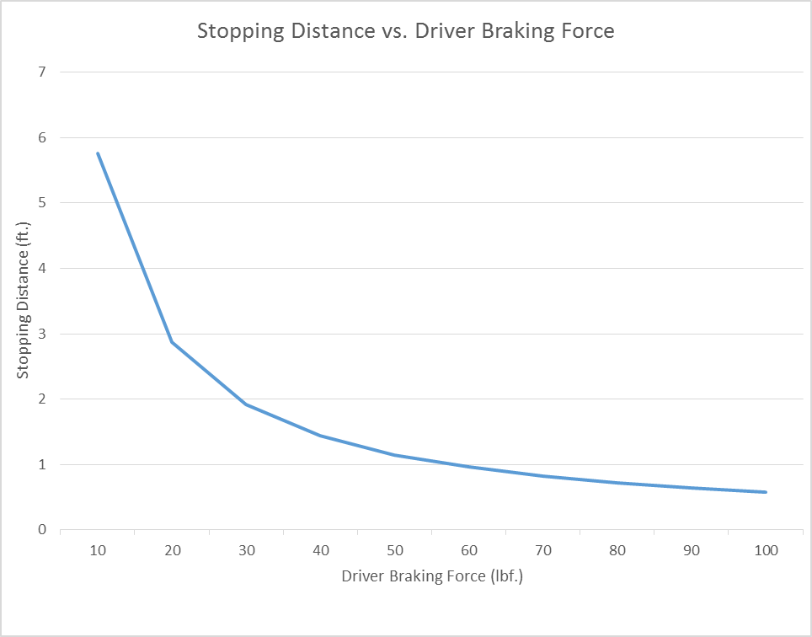

Figure 21. Analysis of stopping distance vs. driver braking force

**iii. Power Linkage**

*Power Input Requirements*

A question of central importance when designing a human powered vehicle is, “how much power must be generated to move the vehicle at the desired speed?” In the case of the Pedibus it is important to know how much power each passenger must generate under different scenarios. The amount of power a person can generate varies greatly between people. Some general numbers of what people can generate are given as reference in table 1. The powers calculated in table 1 are based on average output for one hour of performing the exercise activity. Based on these numbers, and some experimenting on a cycling machine at the gym, it was determined that a constant power output of less than 60W was desirable so that powering the Pedibus was not too tiring.

Table 1. Average Human Power Generated for Activities

|  |  |
| --- | --- |
| ACTIVITY | AVERAGE POWER OUTPUT For 1 Hour (Watts) |
| Walking at 3mph | 30W |
| Average person bike racing | 120W |
| Regular cyclist racing | 220W |
| Professional cyclist racing | 300W |
| Lance Armstrong racing | 400W |

Analysis was done on the power requirements to maintain a cruising speed of 5mph and to accelerate to 5mph from rest. Analysis of the power required per passenger based on total number of passengers and traveling velocity will also be discussed.

*Maintaining cruising speed*

The desired cruising speed for the Pedibus is 5mph. To maintain a speed of 5mph the forces that must be overcome are the force of drag, rolling resistance, and the force required for any change in elevation. If it is assumed that the Pedibus is traveling on level ground and there is no change in elevation then the force of drag and rolling resistance are the only forces. Equation (1) is the equation for calculating the drag force on the Pedibus at a given speed. Assuming $v$ is our desired cruising speed of 5mph and the coefficient of drag ( Cd) is assumed to be 1.05 ( the drag coefficient of a flat plane normal to wind velocity) The force of drag on the Pedibus is found to be 8 N. Using Eq. (2) this represents a power input of about 17W.

$F_{d}=\frac{1}{2}ρv^{2}C_{d}A$ (1)

$P=F*v$ (2)

The force of rolling resistance can be calculated using Eq. (3). The coefficient of rolling resistance (Crr) of the tire chosen for use on the Pedibus is 0.0065. All calculations for rolling resistance were made assuming that the tire would have a higher Crr of 0.01 when supporting the weight of the Pedibus and passengers. With this assumed value for Crr and an assumed loaded weight of 2750lb (weight of Pedibus and eight 250lb passengers) the force of rolling resistance was found to be 123N. To maintain a speed of 5mph it takes 275w of power to overcome rolling resistance. From these values it can be seen that rolling resistance is the dominant resistant force at the velocities the Pedibus is designed to travel at. If all passengers are pedaling with equal power input (equal torque on the pedals at the same rotation speed) each passenger would need to generate 37W of power to maintain a traveling speed of 5mph.

$F_{rr}=Mass*gravity*C_{rr}$ (3)

*Reaching Cruising Speed*

Equation (4) represents the sum of the forces acting against the Pedibus while accelerating. The force of rolling resistance (Frr) and the force of drag (Fd) have already been calculated. The force of acceleration (Fa) is calculated with Eq.(5) . There is no acceleration rate requirements for the design of the Pedibus. The Pedibus team determined that if the Pedibus starting from rest could reach a cruising speed of 5mph 20 seconds that would be sufficient rate of acceleration to accomplish all the need of the Pedibus. This represents an acceleration of 0.367 $\frac{ft}{s^{2}}$. The power required to achive this acceleration varies with traveling velocity. Since acceleration to cruising speed represents such a small portion of the traveling time the Pedibus teams analysis was focused on the maximum power input required to reach 5mph if accelerating at a constant rate of 0.367 $\frac{ft}{s^{2}}$ as opposed to average or total power input required. The max power input required to move the Pedibus from rest to 5mph can be determined using Eq. (6). The maximum power required to accelerate the Pedibus was determined to be 604W. This represents a power input of 75.5W per passenger. While this is above our desired power output of 60W it is for a very short period of time and is thus acceptable.

$F_{total}=F_{d}+F_{rr}+F_{a}$ (4)

$F_{a}=Mass*Acceleration$ (5)

${ P}_{max}=\left(F_{d}+F_{rr}+F_{a}\right)v_{max}$ (6)

*Traveling with less than full capacity*

An objective of this design project, set at the beginning of the semester, was that the Pedibus be able to be power by as few as 2 passengers. The equations mentioned previously in this section were used to generate fig. 22, a graph of the power required to maintain 5mph based on number of passengers, and fig. 23, a graph of the power required to accelerate to 5mph based on number of passengers. From these graphs it can be seen that, while it will require more than double the power, two passengers could accelerate the Pedibus to 5mph with 168 W of power input each, and could maintain it at that speed with 83W of power input each. While these power inputs are higher than the ideal limit of 60W per passenger they are low enough that two people in average shape can power the Pedibus for at least an hour before tiring.

Figure 22. Watts per Passenger to maintain 5mph Velocity vs. Number of Passengers.

Figure 23. Maximum Power Required per Passenger to Accelerate from Rest to 5mph in 20 seconds

*Traveling up an inclined slope*

All analysis on the power requirements for moving the Pedibus discussed up to this point in the report have assumed the Pedibus was traveling on level ground. The topography of Tallahassee is more like that of southern Georgia than it is like that of the rest of Florida in that it has a number of significantly sized hills. Because of this when designing a vehicle to be operated in this area it is not reasonable to assume the vehicle will travel on level ground. Assuming an incline of 7% Eq. (7) can be used to calculate the additional force acting against the Pedibus as it is traveling uphill which was determined to be 931N. This is more than double the force acting against the Pedibus as it travels on level ground and represents an additional power requirement per passenger of 300W per passenger. This mean each of the eight passengers will have to generate 340W of power to climb a 7% incline at 5mph. Referencing table 1 it is clear that very few passengers who travel the Pedibus will be able to generate that amount of power. A slower travel speed is required for traveling uphill. Figure 24 is a graph of power requirement per passenger based on the vehicle velocity being maintained. From the graph it was determined that while traveling up an incline the vehicle speed will have to be reduced to 1 or 2 mph unless electric motor assistance is used.

$F_{slope}=Mass*\sin\left(θ\right)*gravity$ (7)

Figure 24. Power Required to Ascend 7% slope Vs Velocity

*Passenger pedaling RPM Analysis*

Not only is it important that the passengers have a reasonable required power input to move the Pedibus, it is also important that the passenger pedaling rpm also be reasonable. Comfortable pedaling rpm are between 50 and 80 rpm for bicycling and will serve as the range of possible pedaling speeds for the Pedibus. With a tire diameter of 26” the wheels of the Pedibus rotate at 65rpm while the Pedibus is traveling at 5mph. The 3.08:1 gear ratio of the rear differential means the drive shaft spins at 200rpm which is too fast a rotation speed to achieve at the pedaling station. To correct this issue a 3:1 gear ratio will be used between the pedaling station and the drive shaft (the gear at the pedaling station being 3 times bigger than the one on the driveshaft). This gear ratio makes the rpm at the pedaling station 66rpm which is in the middle of our comfortable pedaling range. The variable that govern this ratio are the tire diameter and the rear differential gear ratio. If either of these values are changed the gear ratio between the pedaling station and drive shaft will have to be adjusted. In the final prototype 22” diameter spare tires were used. The smaller tire diameter resulted in a pedaling cadence of ~ 80 rpms to maintain a traveling speed of 5mph.

**IV. Prototype Details**

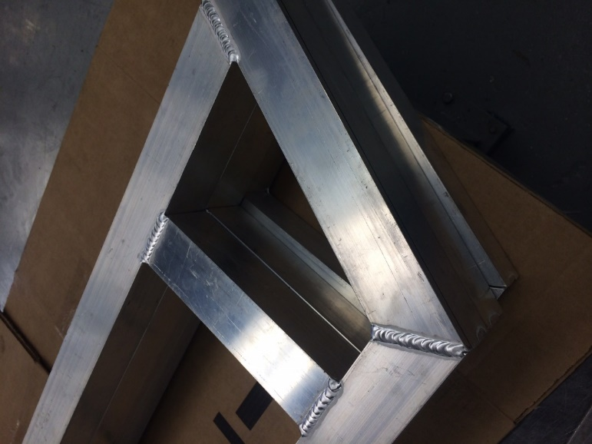 After the initial CAD designs were finalized the assembly process began. The first component to be assembled was the aluminum cross members, the individual sections and pieces to be welded together were carefully cut to the required lengths and angles, and once all of the pieces were ready the welding process began by tack welding the first one and ensuring that it had the correct dimension and then laying the other corresponding parts on top of the initial cross member as a reference to ensure uniform dimensions throughout the cross members.

Figure 25. Picture of the welding process as one cross member is laid upon the initial to ensure uniform dimensions.

Once the cross members were welded, the connection of the steel supports to the front end and the rear differential was the next step. The Front suspensions connection to the steel support did cause some problems since the kit didn’t come with dimensioning parameters for spacing of the upper and lower control arms and in addition to that, the wrong dampers were sent to us and we had to scrub the suspension and make it rigid by a implementing a threaded rod that would hold a constant distance between the upper and lower control arms. Once this was completed the front end could be welded to the steel support beams.

Connection of the rear differential was made possible by water-jetting a bolt plate for the u-bolts to wrap around and tightly fasten the rear differential to the steel supports. To prevent any lateral movement of the differential, rounded seats were also water jetted and welded onto the steel supports for the differential to sit in while it is tightened down by the U-joints.

With the steel supports connecting the front end and rear differential the next step was then to fasten the aluminum cross members to the steel supports. Since we know that steel cannot be welded to aluminum, special brackets were designed to prevent any lateral movement as well as any vertical movement.

Once the placement of the aluminum cross members on the steel supports was finalized the brackets were welded onto the steel beams and the aluminum cross members were bolted to these brackets.

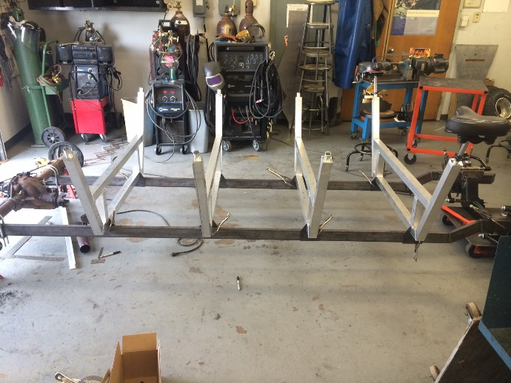After the cross members were fastened to the steel supports the design of the powertrain was able to be mocked up and dimensioned. Fortunately the pillow block bearings, driveshaft, and the corresponding bicycle components fit together without any problems.

The next step was getting the bicycle cranks assembled and fastened to the cross members, once again thanks to effective planning and design this too was as simple as welding them together and bolting them on.

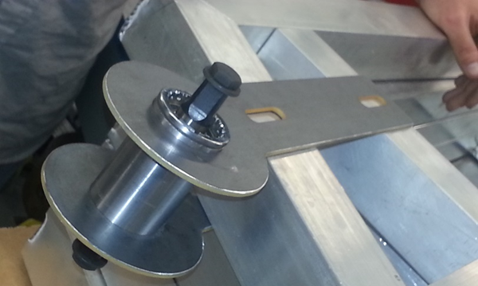 One issue that arose during the construction of the power transmission linkage was that the rear differential was not exactly in line with the central drive shaft, this issue was quickly resolved by the implementation of two u joints at the end of the drive shaft to facilitate the minor offset dimensions of the differential input and the central axis of the driveshaft.

For added rigidity, aluminum supports connecting the aluminum cross members were welded in place to reduce any deflection of the frame with added weight of passengers; Also, the tires and wheels that were sourced from pick n pull were mounted onto the front end and rear differential and the driver’s station seat supports began to be implemented and welded into place.

Figure 26. Bottom bracket mounted to the aluminum cross member

After the foundation for the walk around area and the supports for the driver’s seat were fastened and the plywood walkway was installed. The driver’s seat was mounted directly to the plywood walkway.

The steering column supports were welded to the drivers support beams and three u-joints were used to reroute the steering column into the center of the Pedibus. In addition to the u-joints, steering shaft bearings were incorporated to prevent movement of the steering shaft. The master brake cylinder fluid reservoir was also fastened directly to the driver’s station support beams.

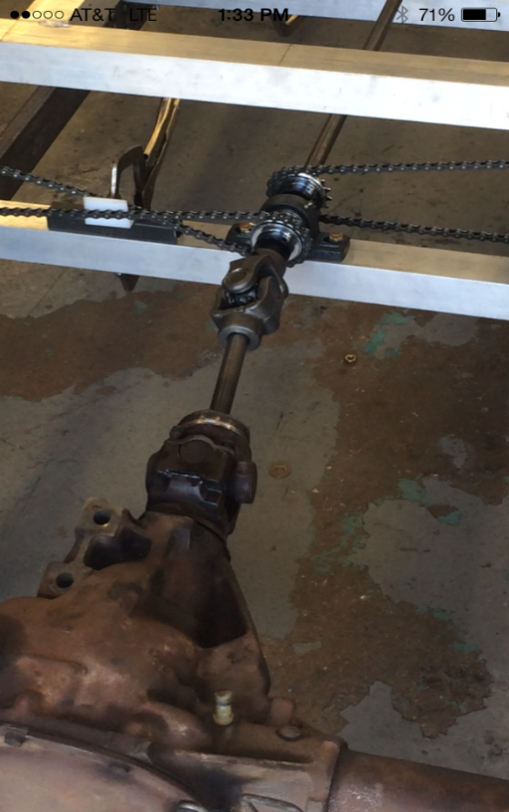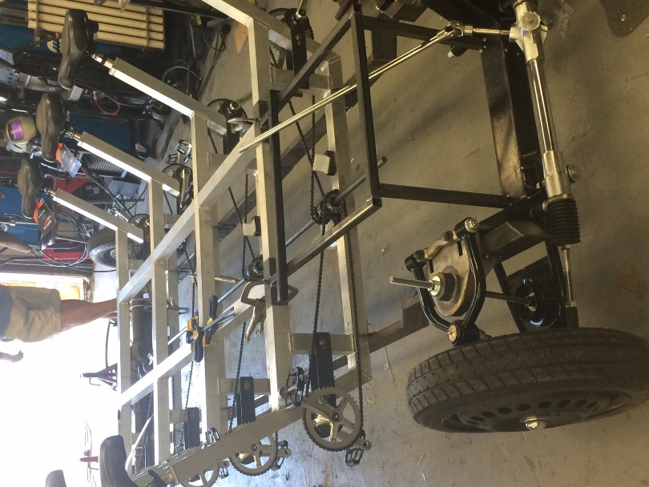

Figure 28. Aluminum supports in place and the driver’s station supports in place and ready to receive walkway plywood.

Figure 27. double u joint connection of the driveshaft to the rear differential to accommodate the offset dimensions.

Finally, a temporary steel structure was assembled to work as handlebars for the passengers of the Pedibus for safety reasons. This structure was only bolted onto the Pedibus to facilitate a hassle free removal of the handle bars.

The Final operational prototype was completed though strong recommendations were made to the sponsor to continue contact with the machine shop supervisor, Jeremy Phillips for any advising on future aesthetics of the Pedibus such as a bar top, rear bench, and roof.

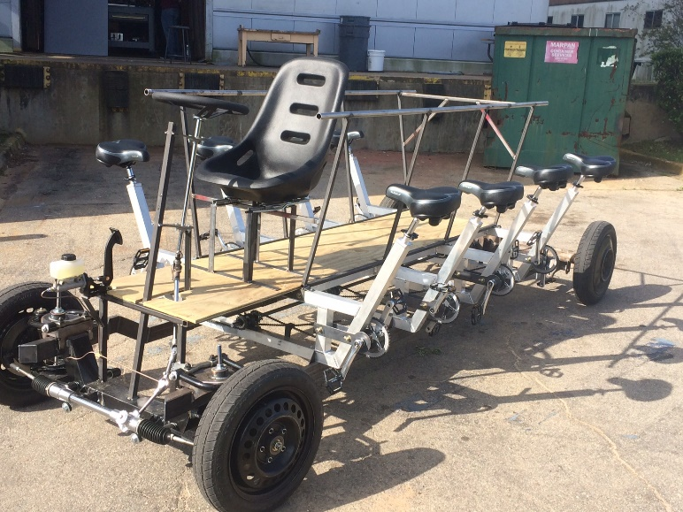

Figure 29. Finalized design of the Pedibus prototype.

**V. Design for Manufacturing, Reliability, and Cost**

**Design for manufacturing**

The manufacturing process should closely follow the assembly process used in the assembly of the prototype mentioned earlier in this report. The manufacturing process should also take place in a machine shop or similar manufacturing facility. Having access to all the tools needed to cut, machine, and weld the metal tubing used throughout the Pedibus assembly is critical to minimizing the time requirements of manufacturing the Pedibus.

As will later be addressed in recommendation section for the report the manufacturing of the Pedibus is made complicated by constructing the structural frame out of both aluminum and steel. An all steel frame would be much easier, cheaper, and faster to manufacture. Tolerances on individual pieces of steel would be reduced as the welding process can make up for errors in cut length in the range of 1/16” to 1/8”. This is the reason we recommend changing the structural frame material to all steel.

To minimize the time required to manufacture a Pedibus all structural frame parts should be cut at once and the welded together. The front end and rear axle should be assembled separate from the vehicle and then both parts attached to the welded structural frame. From this point forward bike parts, steering, and braking components can be added to the Pedibus. By breaking the assembly in to the components an individual technician can focus just on cutting metal and welding or just on assembling front ends etc. with technicians devoted to assembling individual components workflow can be greatly increased and multiple Pedibuses can be manufactured at the same time. This minimizes the cost of labor for an individual Pedibus and increases the production rate of the manufacturing facility.

Another recommendation for increasing the efficiency of the manufacturing process is to redesign the seat post collar attachment. This part is meticulously machined from a block of aluminum and takes several hours to make. Finding a simpler way to attach the seat posts while still making the seat post height adjustable, will greatly reduce cost, build time, and eliminates the need for a trained machinist.

**Design for Reliability**

There are many components included in the Pedibus that have to be maintained and routinely checked upon. As the vehicle is operated by the public people, safety is the number one concern that has to be addressed. The following section is going to discuss steps to be taken to ensure proper mechanics and operation of the Pedibus to validate the safety factor.

**(i) Safety Features**

The Primary safety features of the Pedibus include the automotive grade brakes and the handles which the passengers of the Pedibus will hold onto to while they pedal. Due to the operational range of speed of the Pedibus the brakes were inherently over-built for the conditions of operation that will be experience by the Pedibus and passengers, which is a 7mph cruising speed. Even in the event of a Pedibus over loaded with passengers going downhill has been accounted for and the automotive grade brakes are still very much capable of stopping within a 5 foot distance, provided there is no skidding of the tires.

There will be handles cut into the Pedibus bar top corresponding to each pedaling station to mimic the handlebars of a bicycle to accommodate the familiarity with pedaling a bicycle to the pedaling action used to propel the Pedibus.

Since the freewheels of the chain had to be mounted onto the driveshaft of the Pedibus instead of at the pedaling stations, consequently this means that when a passenger of the Pedibus isn’t inputting pedal power into the pedals of the Pedibus the chain will still be spinning. To prevent any passenger injury, chain guards will be installed around the moving parts of the chain at the pedaling station.

**(ii) Trouble shooting diagnosis and repair**

This document describes the most common problems related to using the Pedibus and information on how to fix or work around the problems. If you are experiencing any problem not described in this document please contact Capitol City Pedicabs for assistance.

Steering & Braking Problems**:**

Description: The steering wheel does not turn the vehicle.

*Cause:*

The steering on the Pedibus is a simple rack and pinion steering. It does not include any power assisted steering, steering fluid, or hydraulic pump. As such there is very little that could go wrong with the steering mechanism and it should be easy to diagnose. The cause for any malfunction in the steering mechanism is most likely the result of a broken steering shaft or U-joint.

*Recommended solution Procedure:*

Locate the U-joint spline connection to the rack and pinion located in front of the front axis of the Pedibus. Ensure that the U-joint is attached to both the rack and pinion steering and the steering shaft. Check the set screws on the U-joint and ensure they are tight. Follow the steering shaft to the U-joint connected on its opposite end of the steering shaft. Check to ensure the steering shaft and steering wheel are firmly attached to this U-joint. After checking all connections turn the steering wheel back and forth and ensure that the steering shaft turns in accordance with this motion. If the steering shaft turns and the wheels do not turn then there is a defect in the rack and pinion or in the rack and pinion steering connection to the front wheels of the vehicle.

Description: The brakes have weak stopping power or don’t stop at all.

*Cause:*

Weak stopping power is most likely the result of low brake fluid in the brake fluid reservoir. Without the appropriate amount of brake fluid the vehicle will first experience weak braking before it loses the power to stop completely. It is very important to check the brake fluid level before operating the Pedibus as there is no other way to safely stop the Pedibus once it is in operation.

*Recommended solution Procedure:*

Locate the brake fluid reservoir on the floor of the Pedibus standing platform to the left of the driver seat. Remove the cap from the brake fluid reservoir and fill the reservoir to the appropriate height indicated by a line on the wall of the reservoir. After replacing the brake fluid be sure to test the brakes by having someone push the Pedibus on level ground while another person repeatedly presses the brake pedal attempting to stop the vehicle. If the brake pedal still has weak or no stopping power do not operate the Pedibus and call Capitol City Pedicabs for assistance.

Pedaling Station Problems:

Description: The pedals at a specific pedaling station do not input power to the vehicle.

*Cause:*

Pedaling at the pedaling station transfers power to the central drive shaft of the vehicle through a bike chain connecting bike gears at both locations. Over time the bike chain will stretch slightly and may become so loose it falls of the bike gear at the pedaling station. This is the most likely cause of a single pedaling station not inputting power to the Pedibus.

*Recommended solution Procedure:*

Look under the chain guard around the pedals of the malfunctioning pedaling station. If there is not a chain visible under the chain guard it means the chain has come loose and is most likely wrapped around the central drive shaft of the vehicle. Looking under the vehicle locate the chain and unwind it from the drive shaft. Now that the thrown chain has been located inspect it for damage (specifically a twisted or broken link that would stop the chain from working properly). If the bike chain is operable proceed to reattach the bike chain.

Locate the two bolts attaching the bike crank to the Pedibus frame. Loosening these bolts will allow the bike crank to slide back and forth allowing you to wrap the bike chain around the pedaling gear and adjust the tension on the chain. After wrapping the bike chain around the pedaling gear slide the bike crank attachment as far back as possible and retighten the bolts. The pedaling station should now be operating properly.

Description: Pedaling at any of the pedaling stations does not input power to the vehicle.

*Cause:*

If none of the pedaling stations are inputting power to the vehicle than it is most likely a problem with the central drive shaft connection to the rear differential.

*Recommended solution Procedure:*

Locate the U-joint connection between the drive shaft and the rear axle. Insure the bolts holding the drive shaft to the U bolt are connected. If the drive shaft has come disconnected from the rear axle install new bolts to reattach the drive shaft. Without this connection being solid none of the power input at the pedaling station can be transferred to the rear axle and the vehicle won’t move. If the drive shaft connection to the rear axle is properly attached and the vehicle still does not move then contact Capitol City Pedicabs for assistance.

Description: The seat post will not stay extended to the appropriate height

*Cause:*

Each seat post is attached to the frame through the seat post collar. The collar is a precisely dimensioned tube with a slit down one side and a clamp to tighten the walls of the tube around the seat post. If the seat post is not remaining fixed at the required length it is most likely because the collar clamp is not attached tightly.

*Recommended solution Procedure:*

Locate the seat post clamp under the bike seat. The clamp should be tightly attached to the seat post collar. If you can apply force to the clamp and it moves that means the clamp is too loose. Open the clamp and tighten the adjustment bolt to make the clamp diameter smaller. Reattach the tightened clamp and check to ensure the seat post is rigidly held in place.

**(iii) Outline for Regular/Routine Maintenance**

In order to ensure safe operation and prevent failure of any component of the Pedibus, certain maintenance needs to be performed. This maintenance is crucial to prolonging the lifetime of the corresponding Pedibus component as well as ensuring that the component is in safe operating condition.

Brake fluid measurements within the brake reservoir need to be checked before each use of the Pedibus, if the fluid level is low the appropriate fluid should be added in a quantity corresponding to the fill line on the reservoir. In the event that the brake fluid runs empty, the Pedibus needs to be serviced by a mechanic to bleed the air out of the brake lines and inspect the braking system to check for brake fluid leaks.

The gear fluid within the gearbox of the rear differential should not need to be changed unless during the pre-ride inspection a leak is found and in that occasion service by the automotive mechanic is required and their approval of the functionality of the differential needs to be obtained before the Pedibus is operated again.

The tension of the chains needs to be checked before each operation of the Pedibus, the chains should have no more than an inch of up and down slack. If the chain is too loose the crank can be slid back to tighten the chain. In the event that the crank chain slack adjustment cannot be adjusted anymore to achieve the desired amount of chain tension, a bicycle mechanic will need to take links out of the chain to achieve the desired amount of chain tension, during the service of the chain the bike mechanic should also be asked to inspect the bike cranks and sprockets to ensure they are in safe operating condition.

The chain needs to be inspected at least once a week to ensure that it is properly lubricated, symptoms of a chain that indicate a need for lubrication include loud squeaky operation of the chain. If the chain is not properly lubricated that shortens the lifetime of the chain, and also adds to pedaling resistance.

Within the front end of the Pedibus there are several points which need to be greased with a regulation grease gun at least once a year, these locations are the upper and lower ballpoints and at the tie rod ends, 6 grease locations in all. This can be done by the mechanic during the annual inspection of the Pedibus.

**(iv) Major Future Repairs and Replacement**

The Pedibus has been designed to minimize the need for maintenance and part replacement. Unfortunately some of the components in the design do have a short enough maximum lifespan that a plan for periodic inspection, repair, and replacement is appropriate. The following components may need periodic repair or replacement.

*Bike chains:*

Every pedaling station has a long bike chain connecting the pedaling gear to the central drive shaft. The length of the chain and the forces acting on the chain will eventually weaken the chain to the point that a link breaks. A chain break may occur at any time and it is recommended that extra chains be stored on the Pedibus. If the Pedibus were to experience a chain break while in operation having extra chains on board would allow for a broken chain to be replaced immediately.

*Bike chain pulleys:*

So that all Pedibus passengers are pedaling forward and still inputting power in the same direction on the drive shaft the bike chains are crossed on one side of the vehicle. To accomplish this chain crossing the chain is split over two bike chain pulleys. Over time the bike chain will wear away at the material of the pulleys and the pulley will eventually fail. Periodic pulley inspection is recommended so a worn pulley can be replaced before it fails.

*Drive shaft free wheel:*

While all of the bike parts being used on the Pedibus are high quality long lifetime parts some parts will eventually break or fail. The free wheel is the most complicated bike part as it allows for power input from only one direction. The free wheel being the most complicated part also makes it the most likely to fail and its location on the central drive shaft makes it the most difficult part to replace. When a free wheel fails it will require that the whole drive shaft be removed so that the free wheel can be stripped from the drive shaft and a new free wheel installed in its place. Due to the large amount of labor involved in completely removing and reinstalling the central drive shaft it is recommended that all freewheels be replaced after one fails. A scenario to avoid is where one free wheel breaks and several hours are spent removing and reinstalling the drive shaft only to have another free wheel break the next time the Pedibus is used. The most effective way of avoiding a situation like this is to replace all the free wheels when one breaks.

**(v) Suggested Spare Parts to Avoid Operational Interruption**

Routine maintenance is highly suggest to secure smooth continual operation of the Pedibus. Provided below is a list of spare parts that are suggested to have available in case of operation error. These parts may either be stored on the vehicle itself for quick access or in a nearby storage facility where the Pedibus will rest.

* *Bicycle chain* – In the case of tension or other functional errors, an extra bicycle chain is high suggest to be stored on the Pedibus for means of quick and accessible replacement. It is important that the chain remains at a firm tension level to produce maximum efficiency at minimal cadence.
* *Master Link* – For ease of extension or reduction of the bicycle chain to ensure proper length, an additional master link is recommended. The master link connects two independent links along the bicycle chain that gives shape to the normal ovular loop pattern of the chain.
* *Brake Fluid* – The Pedibus’s brakes consist of two frontal disc brakes that are controlled by an applied force to the brake pedal. In order for proper translation of the applied force to the disc brakes, the master cylinder must contain an appropriate level of brake fluid. The fluid is then transitioned along the brake lines which enable the compression of the brake pads along the rotor. Being that fluid might leak or become corroded overtime, additional brake fluid is highly suggested to have access to in the case of addition or replacement. Checking the fluid level is also recommended before operation of the vehicle.
* *Nuts and Bolts* – Being that the Pedibus contains numerous parts, additional nuts and bolts are suggested to have on hand for quick access. Majority of the interchangeable and adjustable parts on the pedaling stations are secured by various bolts and screws. In the occurrence of a loose or missing bolts, it is recommended that it be replaced to ensure maximum safety and operation.
* *Seat Post Collar* – Located on the seat post attachment is a plastic adjustable seat post collar. The collar controls the height at which the bicycle seat sits at. Overtime the collars may become loose in compression allowing the seat post to fall further into the frame of the Pedibus and thus not maintaining a proper comfortable seat height. The collars are small enough to store an additional one on the vehicle for ease of quick replacement.
* *General Bicycle Tools* – For future adjustments a standard seat of bicycle tools are recommended to be stored on the Pedibus. These may include a variable toque wrench for all the adjustable bolts and also an allen wrench for seat adjustments.

**Design for Cost**

Table 2 is the bill of materials for an individual Pedibus with costs attached. It can be seem from table 2 that the material costs for an individual Pedibus are less than $5,000.00. this table omits materials that were designed but not purchased for the prototype assembly. Namely parts for the bar top and the roof of the Pedibus are not included and will cost roughly $400.00. Including these costs the material cost for a Pedibus is still below $5,000.00

Table 2. Bill of materials

|  |  |  |  |  |
| --- | --- | --- | --- | --- |
| BOM |  | # | Price Per Item | Total Price |
| Steel Frame |  | 1 | $250.00 | $250.00 |
| Aluminum Frame |  | 1 | $459.00 | $459.00 |
| Pillow Blocks |  | 4 | $30.00 | $120.00 |
| 3/4 inch Cold Rolled Drive Shaft |  | 1 | $100.00 | $100.00 |
| Mustang II Ifs |  | 1 | $1,350.00 | $1,350.00 |
| Rear Axle and Differential |  | 1 | $140.00 | $140.00 |
| Camaro drive shaft |  | 1 | $48.00 | $48.00 |
| Bike Crank |  | 8 | $45.00 | $360.00 |
| Bike Seat |  | 8 | $17.00 | $136.00 |
| Bike Chain |  | 8 | $30.00 | $240.00 |
| Free Wheel gear |  | 8 | $25.00 | $200.00 |
| Wheels & Tires |  | 4 | $17.00 | $68.00 |
| Rear Axle U-Joint |  | 1 | $81.00 | $81.00 |
| 2 U Joint Steering Shaft |  | 1 | $170.00 | $170.00 |
| Additional steering Ujoint |  | 1 | $45.63 | $45.63 |
| U Bolts |  | 4 | $14.00 | $56.00 |
| Brake Pedal and Master cylinder |  | 1 | $133.00 | $133.00 |
| Bottom Bracket Shell |  | 8 | $4.25 | $34.00 |
| Seat post clamps |  | 8 | $8.00 | $64.00 |
| Aluminum Billet |  | 1 | $59.54 | $59.54 |
| Steel round stock |  | 1 | $48.00 | $48.00 |
| brake lines and fluid |  | 1 | $55.00 | $55.00 |
| Steel Plate |  | 2 | $45.54 | $91.08 |
| nuts, bolts, lugs, degreaser |  | 1 | $68.30 | $68.30 |
| **Total** |  |  |  | **$4,376.55** |

To keep the cost of the Pedibus low it is recommended that some parts be recycled from old vehicles. For example the rear axle of the prototype Pedibus was taken from a car at pick n pull and only cost $140.00. While using used parts does decrease the reliability of the vehicle it is important to remember that these parts are designed for use in a vehicle that weighs more than a Pedibus and travels at speeds much greater than that of a Pedibus. Because of this someone with automotive experience who knows what their looking for can easily find a cheap rear axle that will work reliable for many years. This same process could be used for a front end with steering and breaking components lowering the material cost for the Pedibus by over $1,000.00.

Additionally ordering parts in bulk will also lower the cost of manufacturing a Pedibus. A shipment of metal would result in a price much cheaper than the price for metal used in the prototype, seen in table 2. This also holds true for bike components, U-joints, Pillow blocks, etc…

**VI. Considerations for Environmental and Safety Issues**

The sponsor provided the initial idea of the Pedibus to be completely eco-friendly with zero gas or fume contribution. The power input into the vehicle is from passengers pedaling not from the combustion of fossil fuels. While the prototype completed during the past year does not have solar panels or a power assist motor those features a planned for the final model. To prevent the use of gas, the power assist motor will be a high torque electric DC motor powered by a rechargeable battery pack. The use of solar panels to charge the battery pack would result in a completely zero energy vehicle which is the ultimate goal of the project.

The Pedibus has many of the inherent dangers that a regular bicycle has. If a passenger is concerned about their safety it is recommended that they use a helmet as they would on a regular bicycle. The Pedibus will be driving on public roads and thus must apply by the state laws. For the safety of the public the final vehicle should poses headlights, tail lights, turning signals, driver seat belt, and a rear view mirror to monitor rear traffic. To ensure safety to the passenger riders all exposed chain links will be covered by folded sheet metal and handles will be placed on the bar for support.

**VII. Future Recommendations**

The overall development of the Pedibus prototype was very successful and only a few recommendations for future reproduction can be noted. These recommendations will reduce manufacturing time and the scale of difficulty as well and the number of components used. Listed below is a brief description of each recommendation and also the influence that they will have on the Pedibus.

*1. Use a cheaper or simpler front axle.*

The implementation of the mustang II independent front suspension provided a good initial idea and proved to work for operation of the vehicle. The only drawback to the IFS is the bulkiness and total weight of the system. A good recommendation would be the use of a CV axle, as seen in most Mazda Miata’s. The constant velocity joints in the CV axle allow the rotating shafts of the axle to transmit power to the drive shaft at variable angles without an increase of friction or play. These axles are light in weight, simple in mechanics, and relatively cheaper in cost. The rack-and-pinion steering system will not be replaced as it is the simplest design and easiest to maintain.

*2. Construct an all steel structural frame*

An all steel construction of the frame is highly recommended as it will make manufacturing and construction of the Pedibus a lot simpler. The weight savings of doing a combination of aluminum and steel frame is overshadowed by the increased complexity of manufacturing. Making the frame out of all steel will increase the overall total weight of the vehicle, but will show little effect when the Pedibus is fully loaded and operated. The construction of the vehicle will also be faster and simpler, as steel cross members will be able to be welded directly to the steel supports and the custom mounting brackets, as used in the prototype, will no longer have to be used. As steel is cheaper than aluminum, this will also reduce cost in the material.

*3. Changing the gear ratio of the differential*

The maximum speed is currently limited by the pedaling cadence level and not the by power requirement. To resolve this, if a faster vehicle speed is wanted, a lower gear ratio or gear box should be implemented. Lowering the gear ratio will allow more torque to be applied by each individual passenger to the central drive shaft, but will also increase the initial force that will be needed to start the operation of the Pedibus. The more desirable recommendation will be including a gear box into the system. This will also for gears to be dropped during operation so the passenger pedaling will hopefully never surpass the speed of the vehicle and constant tension will be able to be applied, and thus increase maximum speed.

*4. Include a parking brake*

Currently the weight of the vehicle keeps the Pedibus in a fixed location when not in operation. The only fault with the absence of a rear parking brake is if the slightest angle of the floor is felt, the vehicle begins to roll in that direction. The addition of a parking brake will omit this action and allow the Pedibus to be parked in any location, even if an inclination is present. This also promotes a security factor for the operator as well.

*5. Finish construction of roof and bar top*

Due to time limitation and constraints, the aesthetic completion of the Pedibus was not able to be finished. The bar top and roof will be a nice addition for further entertainment purposes but the absence does not affect the overall function of the Pedibus, which is why it was not stressed upon prototype completion. The design for the roof top and adjustable bar have been provided to the sponsor, so no future design process is required only manufacturing and construction.

**VIII. Resources and Budget**

The construction of the Pedibus was performed in the machine shop locating in room A118 of the FSU-FAMU College of Engineering. All resources were provided by the assistance of the machinists which included welding, CMS cutting, water jetting, drill pressing, and various other cutting and fastening tools. This allowed for all manufacturing to be done personally and no outside assembly resources were needed. With the cost of manufacturing being able to be omitted, the following table is a list of the bill of materials and their associated cost.

**IX. Conclusion**

The Pedibus development was very successful in the completion of a prototype as required by the needs assessment provided by the sponsor. The overall structure of vehicle allows for eight passengers to sit at individual pedaling stations and all contribute to the output of the central drive shaft. All mechanical components operate as assumed and no further adjustments are needed or required. The final testing of the completed model proved to match all the calculated performance parameters that were evaluated and analyzed during the design process of the prototype. The total cost of the Pedibus was kept under the self-determined budget as many parts were locally sourced and scraped. The prototype was displayed at the open house presentation and provided enjoyment to any person who joined in the operation of the vehicle. An easy cadence level of the pedals provided minimal work to be applied to the pedals which allows for all ages and body types to assist in operation. The team members and sponsor are elated with the outcome of the final product and was awarded second place at the award ceremony during the open house. The team showed great camaraderie to finish the completion of the project and has gained great knowledge and experience in design and manufacturing.



**Appendix**

List of equations and solutions

Equations:

$F_{d}=\frac{1}{2}ρv^{2}C_{d}A$ (1) Force of drag

$P=F*v$ (2) Power

$F_{rr}=Mass*gravity*C_{rr}$ (3) Force of rolling resistance

$F_{total}=F_{d}+F_{rr}+F_{a}$ (4) Total force to accelerate

$F_{a}=Mass*Acceleration$ (5) Force of acceleration

$P_{max}=\left(F_{d}+F_{rr}+F_{a}\right)v_{max}$ (6) Max Power (accelerating)

$F_{slope}=Mass*\sin\left(θ\right)*gravity$ (7) Force of traveling up slope

Unloaded weight of the pedibus

Assuming everyone riding the pedibus weighs 250lb

Variable for number of passengers



Cruising velocity of 5mph

density of air





Assumed area of 5 ft wide and 5ft tall for front of vehicle









Equation (2) for calculating required power overcome drag at cruising velocity

Equation (1) for calculating drag force

Coefficient of drag for a flat plane normal to the wind direction

coefficient of rolling resistance our tires claim 0.0065 but used 0.01 to be conservative





Equation (3) for calculating rolling resistance force



Required power to overcome rolling resistance based on # of passengers





assumed acceleration of 0 to 5mph in 20 seconds





Equation (5) Force required to accelerate pedibus

rolling resistance force based on # of passengers







Max power required to accelerate

power required approaches this value as velocity approaches 5mph







Power required to accelerate based on # of passengers



Power requires to maintain cruising speed of 5mph



Power required per passenger to maintain 5mph















Force values with eight passengers





total power required with variable velocity



total power required to climb slope based on velocity



Power required per passenger based on velocity



Steering Analysis

Static Load Distribution

The assumed weight distribution is 50/50 front to rear.

Initial assumption of vechile being 140" in total length





Moment being about the center of gravity:







During Cornering:

Centrifical Force = Cf



(minimum assumption)



(maximum angle)



















Braking Analysis

**All inital conditions are based off estimated assumptions











Energy of vehicle in motion into thermal energy





The brake pedal

Assume weight of driver is 180 lbs

Force exerted by driver onto foot pedal:









Bore diameter of master cylinder = bmc





Hydraulic pressure transmitted to the calipers:

(Assuming 100% efficiency)





The Caliper

Piston diameter = dp













The Clamp





The Brake Pads

The coefficient for a brake pad is typically betweenn 0.3 to 0.7

For our concerns we will assume an average of 0.5 for the coefficient of friction (μ bp)







The Rotor

Reff = the effective radius of the rotor (measured from the rotor center of rotation to the center of pressure of the caliper pistons)











Since the effective rolling radius is hard to measure without real-time testing we are going to use the loaded rolling radius instead (center of wheel to contact point with horizontal surface)











Deceleration of Pedibus in motion





The Tire

(Accounts for all four tires)



Stopping Distance



